***WeRateDogs Insights for Dogs’ lovers***

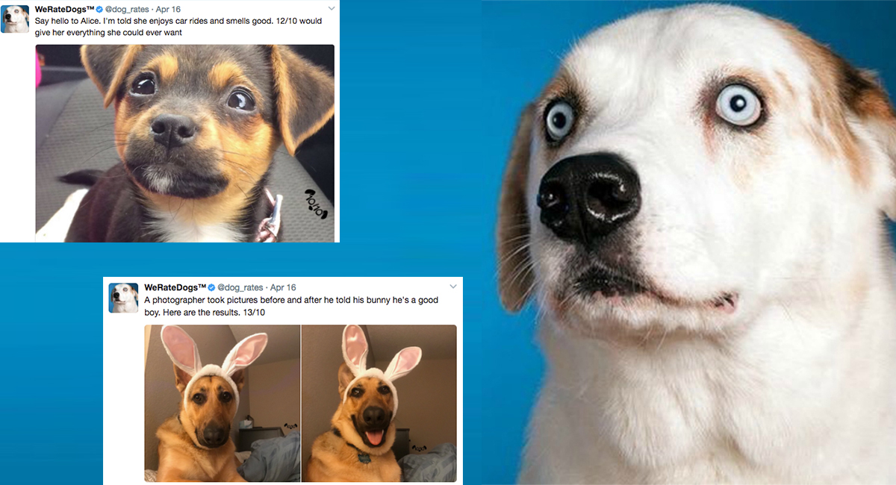

WeRateDogs is a Twitter account that rates people's dogs with a humorous comment about the dog. These ratings almost always have a denominator of 10. The numerators, though? Almost always greater than 10. 11/10, 12/10, 13/10, etc. Why? Because "[they're good dogs Brent](http://knowyourmeme.com/memes/theyre-good-dogs-brent)." If you are a dog lover like me; insights gleaned from this twitter account data introduce some very interesting facts about the account’s ratings, what were the breeds most mentioned or rated in the account’s tweets and how the account’s reach as favorite & retweet count and their followers base increased through the years.

# What were the most frequent ratings given to the dogs?

This account rates dogs on a scale that has a denominator of 10 and a numerator that almost always is greater than 10 ☺. They are magical and loyal creatures that deserve all the love they get. I found out that throughout the years the most given rating was 12, exactly 446 times. In general, the most frequent ratings given to dogs were [12,10,11,13,9] from the highest to lowest. Here is a visualization explaining more.

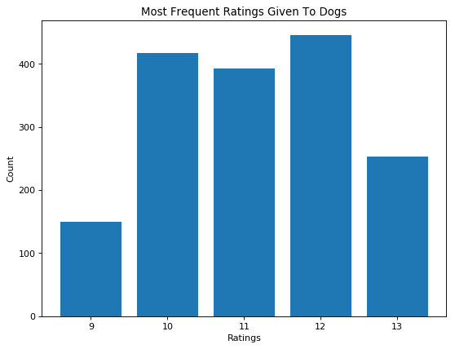

# What were the breeds predicted by the neural network that were most mentioned in tweets?

The image data in the tweets were ran through a neural network that classifies dogs according to their breeds. From golden retrievers to pugs, the neural network classified all the image data. Through analysis of this data I found out that the breed(s) that had the most mentions in the account’s tweets were the retriever ones: Golden and Labrador, with almost 300 mention for each. Here is a visualization to explain more.

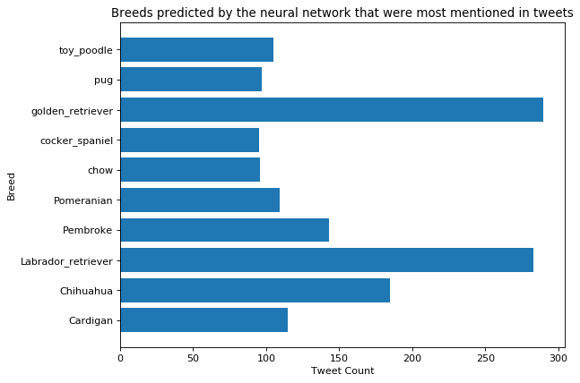

# What is the average retweet and favorite count for the account by year?

I analyzed the account’s data to measure how throughout the years its reach and followers base increased, and found out very interesting insights:

* The account experienced an increase in the number of retweets and favorites each year.
* However, the favorite account was always more which shows that is the easiest and most comfortable for the account followers to show appreciation and love for the account's tweets and the dogs.
* The favorite count also showed a remarkable increase between the year 2016 and 2017 which shows that the number of the followers increased the most during this time for the account.

Here is a visualization to explain more.

